A000-Afr-Kongo-Pende-Mask-Kiphoko-Wood and Raffa-19th c
Note: The Democratic Republic of the Congo has been known as, in chronological order, the Congo Free State, Belgian Congo, the Republic of Congo-Léopoldville, the Democratic Republic of the Congo and the Republic of Zaire, before returning to its current name the Democratic Republic of the Congo or, hereinafter, Congo DR.
Note: The Kongo people (singular: Mukongo, pl. Bakongo) speak Kikongo, a Bantu language, who have lived along the Atlantic coast of Central Africa, in a region that, by the 15th century, was a centralized and well-organized Kongo Kingdom but is now a part of three countries: the Democratic Republic of the Congo, the Republic of the Congo and Angola
141. MASK (KIPHOKO)
Zaire, Pende, western Kasai region, Tsbikapa zone, Kitangwa
Wood, paint, H. II in. (28 cm.)
19^{th -} Z0tb century
The kzloboko mask is a helmet with a flat, projecting lower edge.
It is enhanced with red, black, and white pigment and deco
rated with triangular motifs on the neck and rim. The distinc
tive nose usually protrudes at a right angle to the face, the eyes
are ovoid, and the ears stick out from either side of the head.
These features characterize the abstract style of the Pende of
Kasai (although at times this may be mixed with the kind of
realism seen in Pende roof-pinnacle figures).
Pboko means knife or sword. Kzpboko refers to the sword user
or executioner (ngzmza). But the kipboko mask represents the
%
chief of the community, whose formidable character is sym
bolized by the swords held by the masked dancer.
This mask plays a very important sociopolitical role in the
life of the Pende living in Kasai. It is linked simultaneously to
the power of the chief—even forming one of his attributes, to
circumcision rites (mukanda), and to an ancestor cult relating
it to various aspects of Pende life. It is said that the mask’s
absence from the village can bring on all sorts of disasters.
On the social level, the mask is used at the end of the cir
cumcision ritual. Young initiates eat the last bite of symbolic food off its nose and afterward vow to keep the sacred teachings
of mukanda secret.

The ancestor cult with which the mask is associated encom
passes the healing of various diseases and rites of agriculture,
hunting, and birth. The use of the mask in these ceremonies
reestablishes the balance of life by assuring abundance, pros
perity, and fecundity. Other masks, known aspbumbu yafumu,
gambanda, pbota, munyangi, mabombolo or kindombolo, and kola,
are also connected with ancestral cults, but play different roles.

This mask displays the essential characteristics of the style.
Its appeal is lessened, however, by the discontinuous arcs of
the eyebrows, which normally extend to the base of the cars.
It should be noted, too, that certain Pende carvers treat the
nose differently from the one seen here, by slightly flaring its
nostrils. Both forms are normal, however.
Malutshi Mudiji-Selnge
The Pende, who are comprised of both eastern and western groups, govern themselves along extended family lineages rather than through chiefly authority. Before 1620 when the Kingdom of Lunda forced both groups to emigrate north, the Pende inhabited a strip between the Atlantic Ocean and the Cuanza River, in what is now Angola. Then, in 1885, the Chokwe put pressure on the eastern Pende to emigrate, but the creation of the Congo Free State under European colonials ended this forced removal.

LC Classification: N1099.C6
Date or Time Horizon:
Geographical Area:
Map:
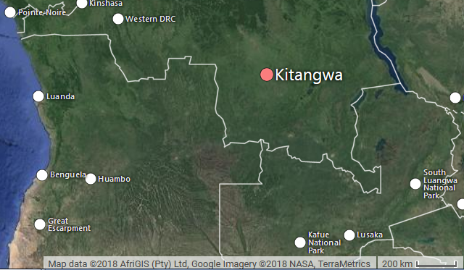
Fig. Map of Pende removal from between the Cuanza River and the Atlantic Ocean to modern D R Kongo after a base map https://upload.wikimedia.org/wikipedia/commons/6/6c/Cuanza.jpg
Fig. Google map of DR Congo showing location of Kitangwa.
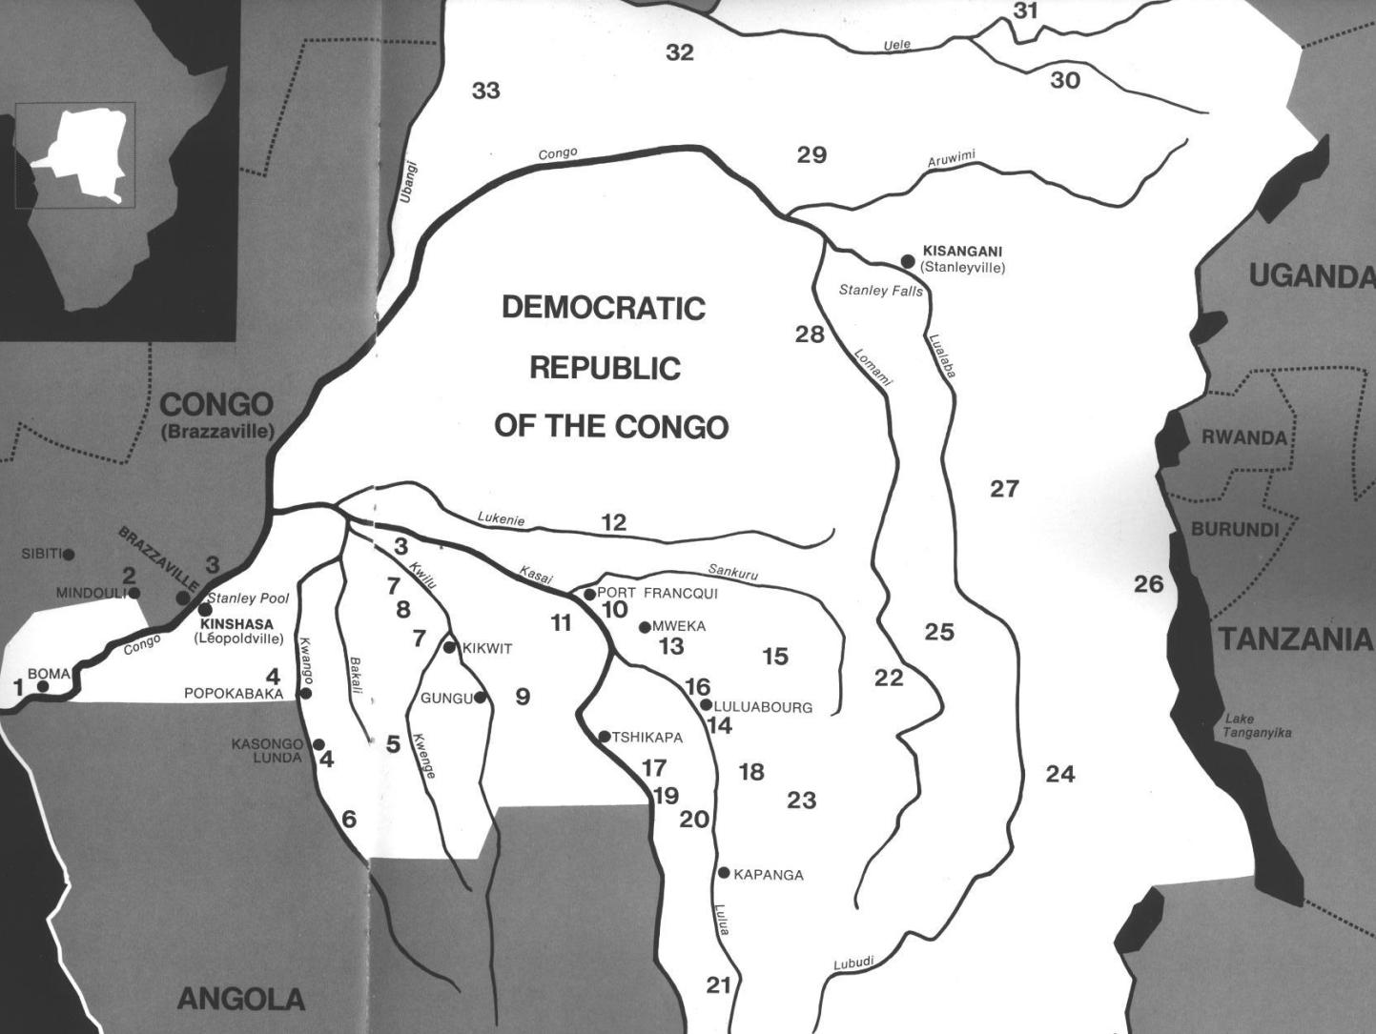
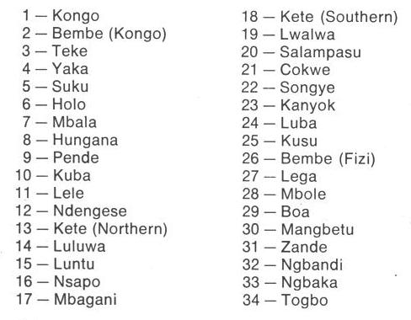
Fig. 1. Map of Kongo Cultures, West Central Africa. After Walker Art Center 1967. 9 is Pende.

GPS coordinates: 7° 46' 19.3" (7.772°) S, 24° 17' 44.9" (24.2958°) E
Cultural Affiliation: Pende, Central Bantu
Media: wood, raffia, kaolin, ferruginous earth
Dimensions: H 20.866 in
Weight: 2.52 pounds
Condition: original
Provenance: Kitangwa
Discussion:

References:
Adams, Monni. 1988. 8th century Kuba king figures, African Art 21(3): 32-38, 88.
Belepe, Bope. 1974. Etude socio-morphologique des masques Bwoom des Kuba: Memoire de licence en histoire. Lubumbashi: Université Nationale du Zaire.
Belepe, Bope. 1981. Les oeuvres plastiques Africaines comme documents d'histoire: Le cas des statues Royales Ndop des Kuba du Zaire, AfricaTervuren 25 (1): 9-17.
Binkley, D. 1987. Avatar of power: Southern Kuba masquerade figures in funerary context, Africa 57 (1).
Binkley, D. 1990. Masks, space and gender in southern Kuba initiation ritual, Iowa Studies in Art. Vol. 3, Art and Initiation in Zaire. Iowa City: The University of Iowa.
Brett-Smith, Sarah. 1983. “The Doyle Collection of African Art,” Record of the Art Museum, Princeton University, 42(2): 2+8-34.
Kuba du Zaire, Africa Tervuren 27(1): 9-17.
Binkley, D. 1987. Avatar of power: Southern Kuba masquerade figures in funerary context, Africa 57 (1).
Binkley, D. 1990. Masks, space and gender in southern Kuba initiation ritual, Iowa Studies in Art. Vol. 3, Art and Initiation in Zaire. Iowa City: The University of Iowa.
Claerhout, A. 1976. Two Kuba wrought-iron statuettes, African Art IX (4): 60-64.
Cornet, J. 1972. Art de l'Afrique Noire au pays du fleuve Zaire. Brussels: Arcade.
Cornet, J. 1975. Art from Zaire: 100 Masterworks from the National Collection. New York: African-American Institute.
Cornet, J. 1982. Art royal Kuba. Milan: Sipiel.
Ehret, Christopher. 2002. The civilizations of Africa: a history to 1800. Charlottesville: Virginia: University of Virginia Press.
Forbath, Peter. 1977. The River Congo. Boston: Houghton Mifflin.
Laman, Karl. 1953. The Kongo. 4. vols. Stockholm: Victor Pettersons.
MacGaffey, Wyatt. 1986. Religion and society in central Africa: the Bakongo of Lower Zaire. Chicago: University of Chicago Press.
MacGaffey, Wyatt. 1988. “Complexity, astonishment and power: the visual vocabulary of Kongo minkisi,” Journal of African Studies, (14:2), 188-203.
Martinez-Ruiz, Barbaro. 2013. Kongo Graphic Writing and other Narratives of the Sign. Philadelphia: Temple University Press.
Rosenwald, J. B. 1974. “Kuba king figure,” African Art, VII (3).
Schadeberg, Thilo. 1999. “Batwa: the Bantu name for the invisible people.” In Challenging Elusiveness: Central-African Hunter Gatherers in a Multidisciplinary perspective, ed. K. Beibrouck, S. Elders, and G. Rossel. Leiden: CNWS, 21-39.
Thompson, Robert Farris. 1978. “The Grand Detroit N’kondi,” Bulletin of the Detroit Institute of Arts 56 :4, 206-217.
Torday, E. and T. A. Joyce. 1911. « Notes ethnographiques sur les peuples communement appeles Bakuba, ainsi que sur les peuplades apparentees, les Bushoongo. » In Annales du Musee Royal du Congo Belge, Ethnographie et Anthropologic., serie III, tome II, fasc. 1. Brussels: Tervuren.
Vansina, Jan. 1955 “Initiation Rituals of the Bushong,” Africa 25(2): 138-153.
Vansina, Jan. 1964. Le royaume kuba. Tervuren: Musée royal de l'Afrique centrale.
Vansina, Jan. 1978. The children of Woot. A history of the Kuba peoples. Madison: University of Wisconsin Press/Dawson.
Vansina, Jan. 1984. Art History in Africa. London: Longman.
Van Wing, Joseph Hubert Leopold. 1941. Études Bakongo. II. Religion et magie. Institut royal colonial belge. Section des sciences morales et politiques. Mémoires, collection in-8°, t. IX, fasc. 1. Brussels: Desclée de Brouwer.
Van Wing, Joseph Hubert Leopold. 1959. Études Bakongo. Brussels: Desclée de Brouwer.
Walker Art Center. 1967. Art of the Congo. Minneapolis: Walker Art Center.

